**Data Structures**

BS (DS) Fall 2022

**Lab - 04**

**Lab Objectives**

Abstract Data Types

Doubly Linked List

# Lab Tasks

## Task 01 – AM I A PALINDROME?

1. Take an Integer number from user of odd length

***Example : 12321 or 3456234781***

1. Convert this number into a Doubly Linked list by inserting each digit in a separate node
2. Check if this list is palindrome or not

***Example : 12321 is a palindrome***

***Example : 3456234781 is a not a palindrome***

1. If the list is palindrome
   * 1. Find out the middle node
     2. 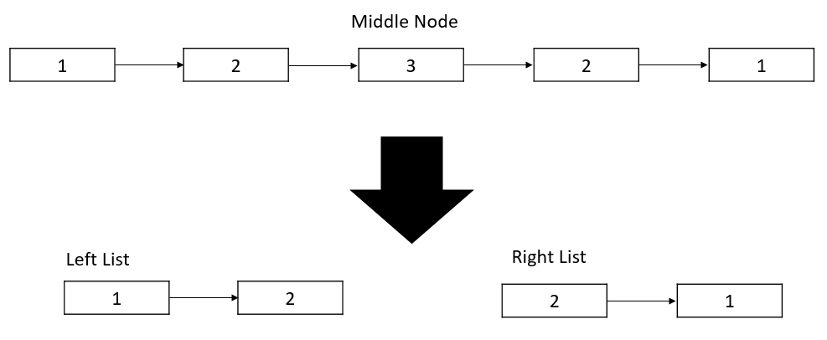Convert this list into two separate double linked lists and display values of both list
2. If list values are not palindrome
   * Find out the middle node and delete it
   * Take sum of all nodes
   * 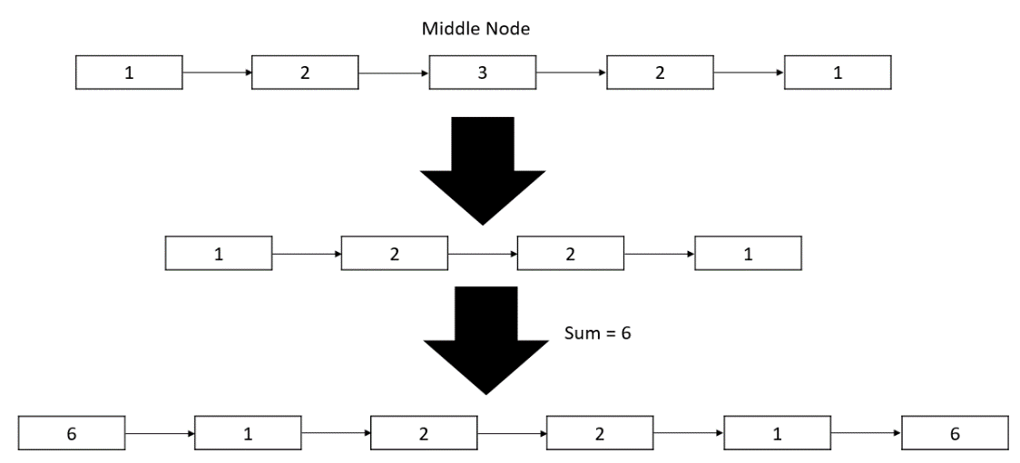Add a node at start and end of the list having value equals to the sum